Module highlights:

1. Any battery and lithium battery of 6-60V can be used;

2. LCD display, battery voltage, charging percentage and charging time are clear at a glance;

1. The function is very powerful, it can automatically control the charging, can control the charging time, and can set and upload the corresponding parameters through the serial port;

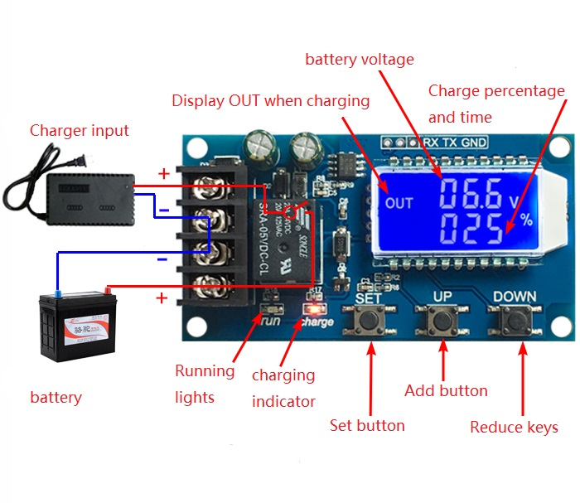

Function Description

1. Automatic charging control function:

By setting the upper limit voltage UP and the lower limit voltage dn; when the battery voltage ≤ the lower limit voltage dn, the relay is turned on, and the charger starts to charge the battery; when the battery voltage ≥ the upper limit voltage UP, the relay is disconnected to complete an automatic charging;

2. Charging time control function:

How to turn on the time control function?

After entering the parameter setting, if the parameter OP is not 0, the time control function is turned on. The default parameters of OP are: --: --h, the time control function is not turned on by default;

After the time control function is turned on (OP is not 0), when the battery voltage is less than the lower limit voltage dn, the charger starts to charge the battery and the system starts timing; during the timing, the battery voltage ≥ the upper limit voltage UP, the relay is disconnected; if the battery voltage ＜upper limit voltage, but the charging time is up, the relay is off; if the OP time is up, the battery voltage is still less than the lower limit voltage dn, the relay remains on, the charging time control function is automatically closed, and H:ER flashes to remind the user that the time Unreasonable parameter settings; press any key to stop flashing;

Note: Time format: 00:59 (00 stands for hours, 59 stands for minutes) The longest time is 99:59, which is 100 hours.

3. Serial data upload and parameter setting function:

The system supports UART data upload and parameter setting function (TTL level);

UART: 115200,8,1

|  |  |
| --- | --- |
| COMMAND | FUNCTION |
| on | Relay use open |
| off | Relay use closed |
| start | Start data reporting function |
| stop | Stop data reporting function |
| read | Get system parameters |
| dw10.0 | Set lower limit voltage |
| up20.0 | Set upper limit voltage |
| xx:xx | Set the charging time and turn off the charging time control function at 00:00 |

Data upload message format:

Battery voltage + battery percentage + charging time + charging status

12.0V,020%,00:10,OP

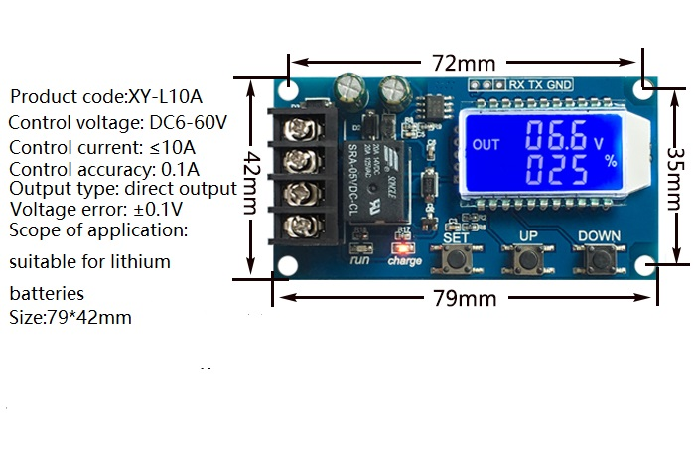

parameter settings

a) Long press the SET button to enter the parameter setting interface, the LCD will display SET;

b) After entering the parameter setting interface, short press the SET key to switch the set parameters;

c) After selecting the parameter, you can set it through the UP/DOWN key, and support short press and long press (rapid increase or decrease);

d) To set other parameters, repeat steps b) and c);

e) After setting all parameters, press and hold the SET button to exit and save;

Button function description

In the running interface (main interface),

Short press the SET button to display the currently set parameters;

Short press the UP button to switch to display the charging percentage and charging time;

Short press the DOWN button to choose to turn on/off the relay enable. If the relay enable is off, it will display ‘OFF’ to remind you that the relay is off;

Long press the UP button to set the status of the LCD backlight (L-P), OFF: the backlight is always on, on: the backlight will automatically go out after 5-10 minutes;

Long press the SET button to enter the parameter setting.

Calculation of voltage percentage: battery voltage/(upper limit voltage-lower limit voltage)

Additional features

a) Charging time recording function: When the charging time control is not turned on, the product will record the complete time once. When entering the time display interface, the charging time will be displayed flashing; it will be cleared when the time display interface is exited or the next charging is turned on (relay is turned on) ；

b) Automatic parameter detection: When the parameters are set and exit, if the lower voltage limit dn ≥ the upper limit voltage up, the system will flash "ERR" to remind;

c) Battery access detection: This product is attached to the battery. If the battery is not connected, the system will display "nbE" in the lower line to remind;

Common failure analysis

Q: How much V level is suitable for use? How much V voltage is suitable for this module?

Answer: This model is suitable for use in the voltage range of minimum 6V and maximum 60V, and the maximum expenditure level is 48V, because a 48V battery is fully charged at about 60V, and it will burn at a higher level. If your battery is higher than 48V, please choose other models.

Question: The relay pops after power-on! The indicator light flashes?

Answer: This is because your charging current is too large or the battery capacity is too small. The upper voltage limit is reached immediately after power-on. The relay is disconnected. After disconnection, the voltage drops rapidly to the lower voltage limit, and the charging starts again. The cycle repeats. When you need to reduce the charging current, usually the charging current is 1 to 1.5 of the battery capacity, such as 20AH battery charging current is generally around 2-3A! Note that high-current charging will cause the battery to heat up, accelerate aging, bulge or even explode!

Q: What control method? Can it be recharged automatically? Can I charge while using it? Can it limit the current?

Answer: This is voltage control. For example, set the lower limit of voltage to 12.0V and upper limit of voltage to 14.5V. When the voltage is charged to 14.5V, the power will be cut off, and the voltage will be reduced to 12.0V. The relay will close and start charging. The method only serves to turn off and turn on, and cannot limit the current. The charging current depends entirely on your charger!

Q: Can input 12V charge 24V battery, or input 48V can charge 12V battery?

Answer: This model is a simple voltage controller, which only functions as a switch and cannot change the voltage to charge the battery, so you must prepare what kind of charger you want to charge the battery! necessary!